SOFTWARE PROJECT MANAGEMENT
What is a Project?
  - A project is a planned undertaking with clear objectives, specific start and end dates, and defined resources.
  - It is temporary and aims to create a unique product, service, or result.
- Key characteristics:
  - Non-routine
  - Planned
  - Targeted
  - Customer-oriented
  - Multi-disciplinary
  - Made up of different phases
  - Time and resource-constrained
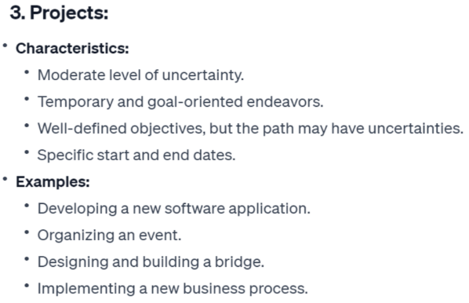
Jobs vs. Projects
- Jobs: Repetitive tasks with little uncertainty.
- Projects: Unique, temporary efforts with specific goals.
- Exploration: Highly uncertain tasks (e.g., research).
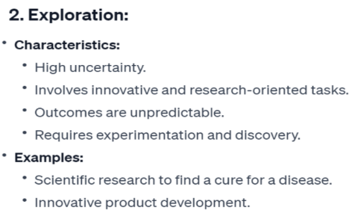
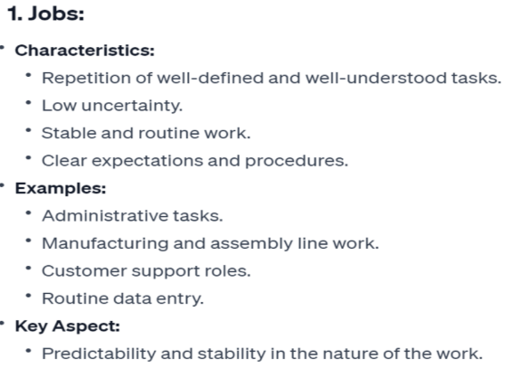

Is Software Project Management Different?
Yes, due to four key challenges:
- Invisibility: Progress is not physically visible.
- Complexity: Software is more complex per dollar than most engineered artifacts.
- Conformity: Must align with human/client requirements.
- Flexibility: Software is highly prone to change.

PMI Knowledge Areas:
An identified area of project management defined by its knowledge requirements and described in terms of its component processes, practices, inputs, outputs, tools, and techniques.
- Scope Management: Defines what the project will deliver.
- Schedule Management: Plans and controls the timeline.
- Cost Management: Manages budget and prevents overruns.
- Quality Management: Ensures deliverables meet standards.
- Resource Management: Identifies and manages team and resources.
- Communication Management: Ensures effective information flow.
- Risk Management: Identifies and mitigates project risks.
- Procurement Management: Manages external vendors and contracts.
- Stakeholder Management: Engages and manages stakeholders.
- Integration Management: Coordinates all project elements into a unified plan.
- Scope Management: (What work is included?)
Collect requirements, define scope, create WBS (Work Breakdown Structure), validate scope, control scope. Define project objectives and activities need to be completed.
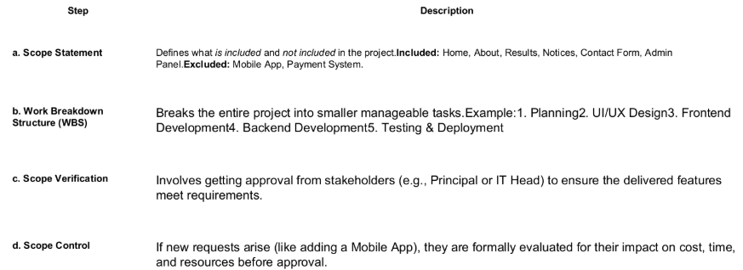
- Schedule Management (When will it be done?)
Define activities, sequence activities, estimate durations, develop schedule, control schedule
Schedule Management is the process of planning, developing, managing, and controlling the timeline of a project — to ensure it’s completed on time.
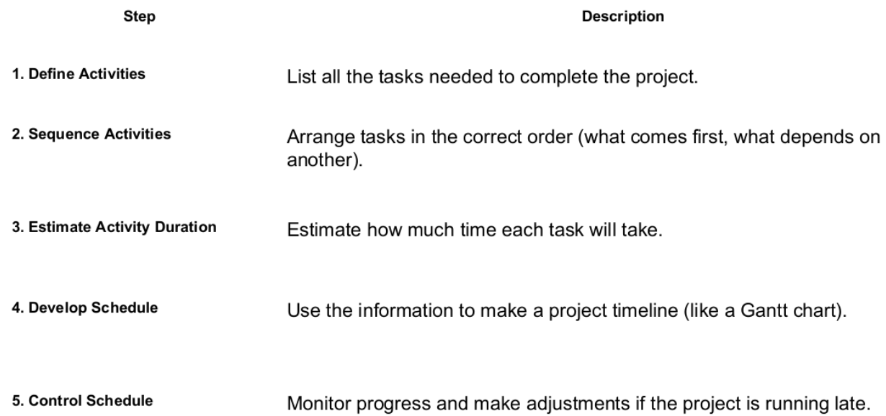

- Cost Management (How much will it cost?)
- Processes required for preparing and managing the budget for the project
- It is important that the project remains within the budget
- Monitor projects to ensure projects progress while remaining within budget
- Prevents overruns, ensures resource efficiency, builds stakeholder trust.

- Project Quality Management (How will we ensure it works correctly?)
- Define quality standards and metrices
- Implement different methods to ensure quality
- Monitor and verify deliverables against quality criteria

- Project Resource Management (Who will do the work and with what?)
- Identify resources required to complete the project
- Acquire these resources and use them efficiently to complete the project
- Identify resources, acquire team, develop team, manage team, control resources

- Communication Management (Who needs what information and when?)
- Successful projects require regular and continuous communication
- Decide how and what to communicate with each member of team
- Use different mediums for communications like github, face to face, boards, email, daily standup meeting and many more
- Procurement Management (What we need to buy from outside?)
- The process of acquiring goods, services, or results from external vendors or partners that are necessary for completing the project.
- Plan procurements, conduct procurements, control procurements.
- Risk Management (What could go wrong and what will we do?)
Identify risks, perform qualitative & quantitative risk analysis, plan risk responses, implement responses, monitor risks.
- Stakeholders Management (Who can impact the project and how?)
Includes the processes required to identify the people, groups, or organizations that could impact or be impacted by the project, to analyze stakeholder expectations and their impact on the project, and to develop appropriate management strategies for effectively engaging stakeholders in project decisions and execution.
- Integration Management (Who can impact the project and how?)
- It effects or effected by all other knowledge areas
- The process of coordinating all project processes and activities to ensure they work together effectively.
- Create a unified and consistent project plan that balances scope, time, cost, quality, resources, and risks.

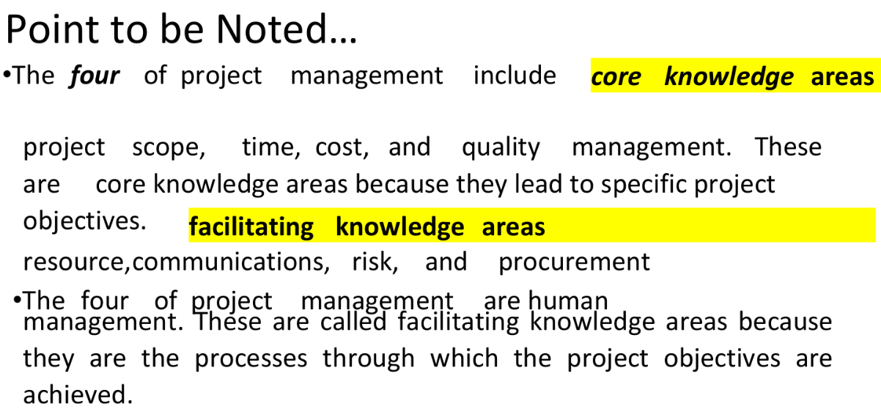

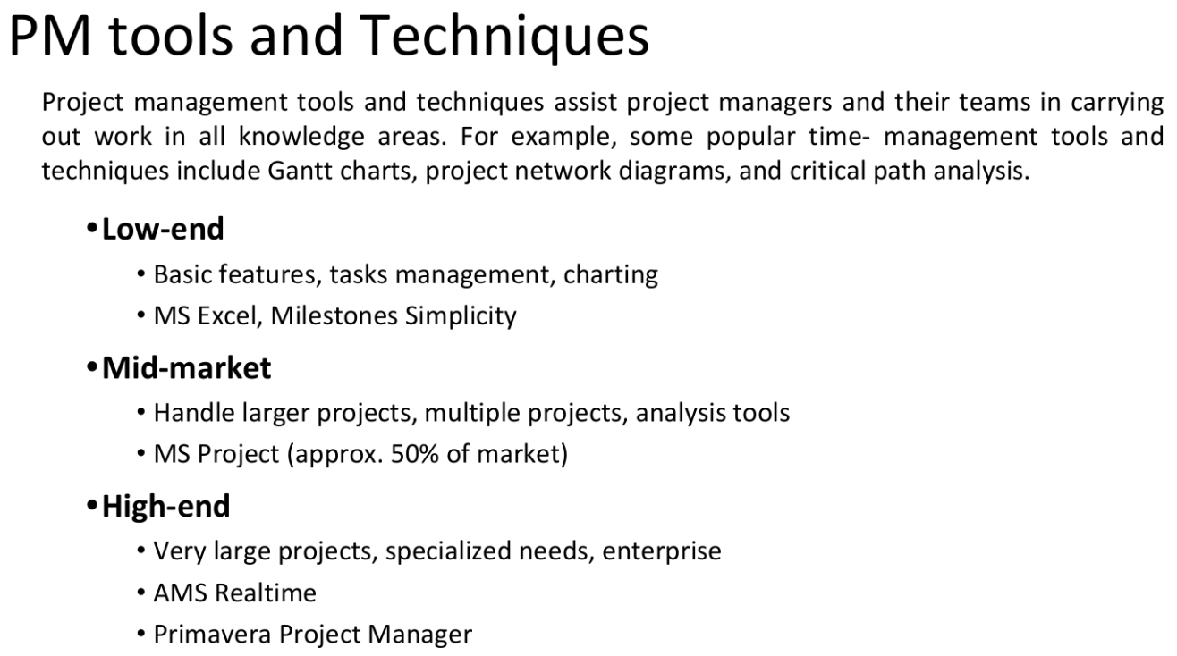
Classical mistakes in Software Development
People-Related Mistakes:
- Undermined Motivation: Poor leadership, unrealistic demands.
- Weak Personnel: Hiring unskilled team members.
- Uncontrolled Problem Employees: Not addressing toxic behavior.
- Heroics: Over-relying on a few “hero” developers.
- Adding People to a Late Project: Increases communication overhead (Brooks’ Law).
Process-Related Mistakes:
- Overly Optimistic Schedules: Unrealistic deadlines.
- Insufficient Risk Management: Ignoring potential issues.
- Contractor Failure: Poor vendor relationships.
- Insufficient Planning: Rushing into development.
- Short-Changed Quality Assurance: Skipping reviews and testing.
- Omitting Tasks in Estimates: Forgetting less visible tasks.
- Code-Like-Hell Programming: Prioritizing speed over quality.
Product-Related Mistakes:
- Requirement Gold-Plating: Adding unnecessary features.
- Feature Creep: Uncontrolled addition of features.
- Developer Gold-Plating: Using unnecessary new technologies.
Technology-Related Mistakes:
- Silver-Bullet Syndrome: Believing one tool/method solves all.
- Overestimated Savings from New Tools: Ignoring learning curves.
- Switching Tools Mid-Project: Causes rework and delays.
- Lack of Version Control: Leads to conflicts and lost work.

